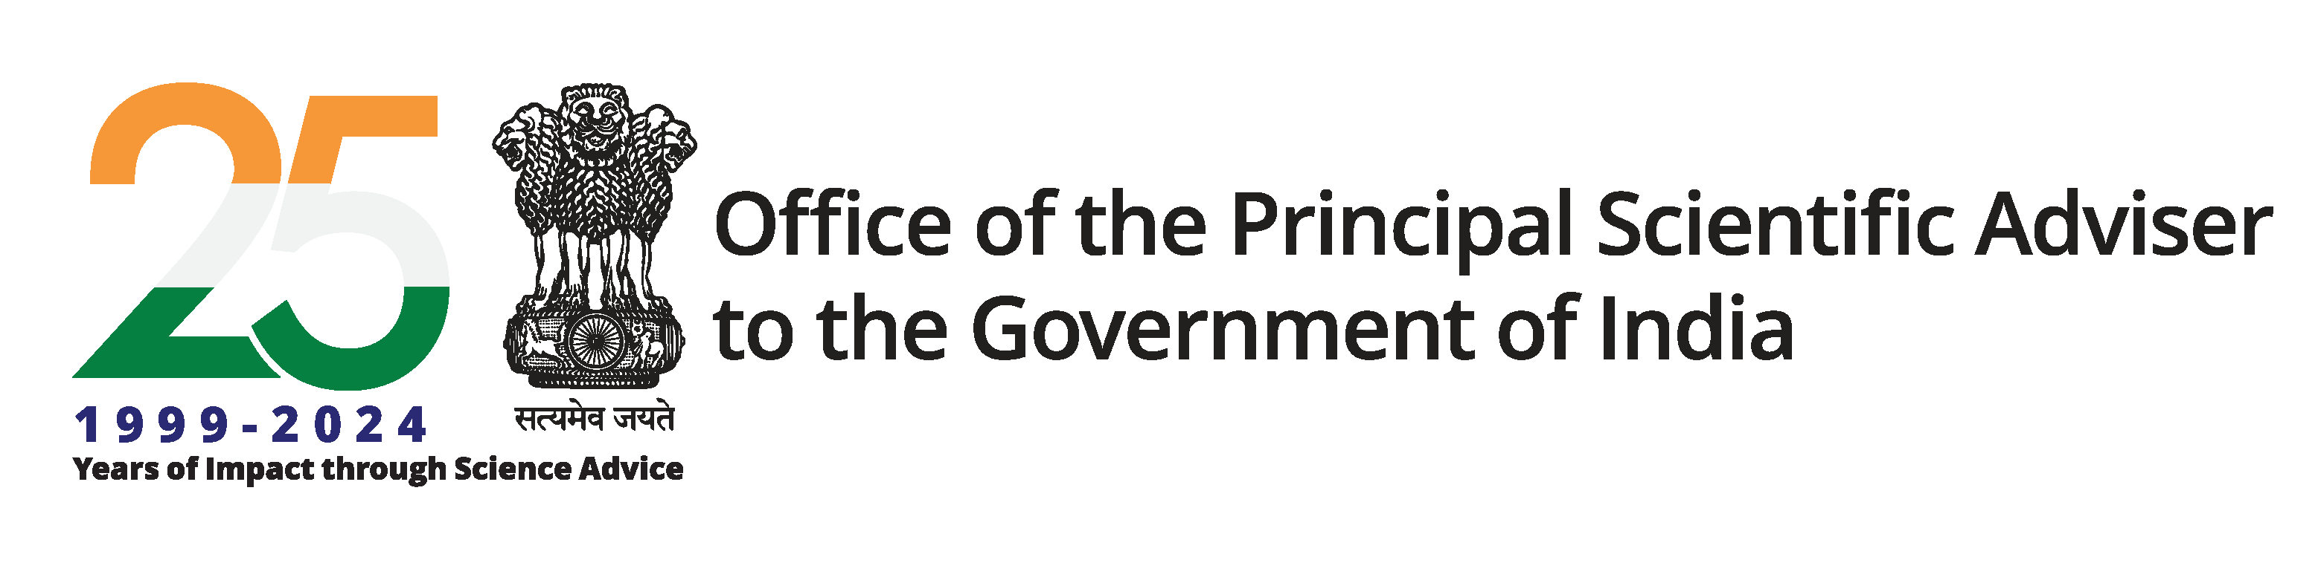

Science and Technology (S&T) Clusters: Overview and Impact

Table of Contents

1. Introduction 3
2. Scope of the S&T Clusters 6
3. Responsibilities of the S&T Clusters 7
4. Impact of S&T Clusters 7
4.1 Success stories 8
4.2 Compendiums 10
5. Conclusion 10
6. Bibliography 12

Introduction
A cluster refers to a group of similar entities brought together by shared purpose or proximity, which underpins the concept behind the development of Science & Technology (S&T) city Clusters. This initiative, a flagship program of the Office of the Principal Scientific Adviser (OPSA) to the Government of India, was launched following recommendations from the Prime Minister’s Science, Technology, and Innovation Advisory Council (PM-STIAC). These Clusters aim to bring together relevant stakeholders with aligned innovative ideas. The cities are chosen based on the presence of dynamic institutions and subject-matter experts, each demonstrating leadership and success in institutional or personal goals.
The S&T Clusters function through a consortium-based model aimed at addressing local challenges via collaborative, science-driven solutions. This initiative brings together academia, R&D institutions, industry and local governments to implement regional interventions using S&T tools. Acting as key platforms for collaborative research, the Clusters support both local and global problem-solving efforts while contributing to the broader goal of “Atmanirbhar Bharat”. Their structure follows a three-tiered pyramid model: the foundational tier builds a shared ecosystem among institutions; the intermediate tier emphasizes regional problem-solving; and the top tier aspires toward national and global competitiveness. By leveraging collective strengths and resources, these Clusters aim to deliver significant economic and societal benefits.
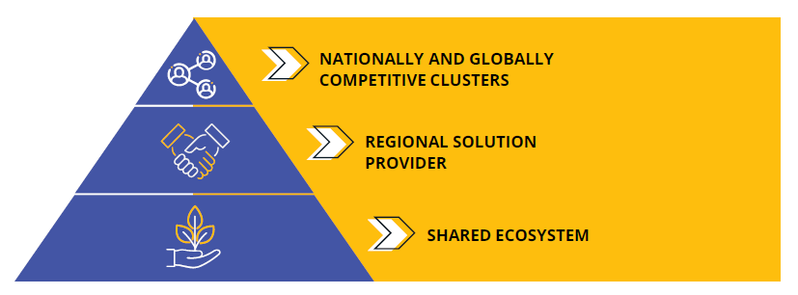
To achieve these goals, each S&T Cluster integrates a wide range of stakeholders, including academic institutions, research labs, industry partners, start-ups, MSMEs, state governments, philanthropic organizations and international entities. Operating under a formal legal framework, the Clusters maintain internal autonomy while facilitating structured collaboration. Each Cluster is defined by a unique thematic focus, specific Research and Innovation (R&I) agendas and strategic partnerships across sectors. As of now, eight S&T Clusters have been established across India.

Sr. No. | Cluster Official Name | Date of Establishment | Verticals  (Phase I) | Verticals  (Phase II)
1. | Research and Innovation Circle of Hyderabad (RICH) | 29/07/2020 | - Food & Agriculture  - Life sciences  - Sustainability | - We to Me Health Tech  - Green Economy  - Smart Farming
2. | Jodhpur City Knowledge and Innovation Cluster (JCKIC) | 29/07/2020 | - Medical Technology  - Water & Environment  - Handicrafts & Handlooms  - I-Governance  - AIOT Innovation Hub  - Thar DESIGNS | - Handicraft & Handloom  - Medical Technologies  - Rain water harvesting and Conservation
3. | Pune Knowledge Cluster (PKC) | 29/07/2020 | - Sustainability & Environment  - Big Data & AI  - Capacity Building  - Health  - Sustainable Mobility | - Water Management and Security  - Plastic Waste Management.  - Industry Connect (Green Hydrogen Innovation Cluster)
4. | Delhi Research Implementation and Innovation (DRIIV) | 07/12/2020 | - Air Pollution Management in Delhi  - E-mobility  - AI/ML in Healthcare  - Effective Education  - Water Security  - Solid Waste Management | - Ensuring water security for Delhi NCR  - Critical and Emerging Technologies  - Clean Energy Transition and Environmental Sustainability  - Using technology for improving public healthcare
5. | Bhubaneswar City Knowledge and Innovation Cluster (BCKIC) | 11/01/2021 | - Biosciences  - Polymer-based Intervention  - Advanced Materials  - Wetland Management  - Waste to Value  - Grassroots Level Interventions | - Affordable Healthcare for All  - Future Economy  - Industry Connect  - Sustainable Tribal Livelihood Network Project
6. | Bengaluru Science and Technology Cluster (BeST) | 06/09/2022 | - One Health  - Precision Agriculture  - Digital Health | - Phase-1 ongoing
7. | PU IIT Ropar Regional Accelerator for Holistic Innovations (PI RAHI) | 09/08/2023 | - Agriculture and Food Processing  - Indigenous Technology Development & Optimization  - Pharma/ Healthcare & Medical Devices  - Waste Management & Wealth from Waste  - Sustainable Mobility & Green Energy | - Phase-1 ongoing
8. | Vizag S&T Cluster (AMTZ) | 22/08/2024 | - New Materials Development for High-Tech Medical Segments  - Industry 4.0 and Automation  - E-Waste Management | - Phase-1 ongoing

This document presents a comprehensive overview of the activities undertaken by S&T Clusters across the country. It highlights their strategic contributions toward addressing pressing societal challenges through collaborative, technology-driven solutions. By leveraging interdisciplinary expertise and fostering innovation ecosystems, these Clusters play a pivotal role in translating scientific advancements into impactful outcomes that improve quality of life. This document aims to assess both the scope and the tangible impact of S&T Cluster initiative, while identifying key areas where accelerated technological intervention is critical for sustainable national development.

Scope of the S&T Clusters
The S&T Clusters in India are institutionalized as Section-8 not-for-profit companies, enabling them to mobilize funding from both public and private sectors. Led by Chief Executive Officers (CEOs) or Chief Operating Officers (COOs), these Clusters are tasked with building robust multi-stakeholder networks comprising industry leaders, start-ups, incubators, public sector undertakings (PSUs), MSMEs, local administrative bodies, state governments, central ministries and philanthropic organizations. In addition to resource mobilization, Cluster leadership is responsible for formulating strategic roadmaps that align regional innovation priorities with national development goals. These Clusters are envisioned as catalytic hubs for regional innovation and national development, aimed at bridging the gap between research, technology and societal application. They are encouraged to develop their own vision and mission statements, outlining how they aim to foster a vibrant and robust S&T ecosystem both regionally and nationally. This concept manifests taking up those problems only for which there is a taker of the solution (demand-driven approach), and which otherwise could not be solved without serious S&T efforts and by entities working in silos.
The Cluster has a multidisciplinary team of scientists, technology managers and domain experts to oversee functions such as project management, technology development, legal affairs, outreach and communications and business development. Their scope extends across multiple sectors including healthcare, agriculture, environment, digital technologies, energy and manufacturing. By leveraging local strengths and fostering cross-disciplinary collaboration, these Clusters enable the co-development and deployment of context-specific, scalable solutions. Furthermore, they serve as enablers of knowledge exchange between academia and industry, accelerators for start-ups and MSMEs, and facilitators of skilling initiatives aligned with frontier technologies. Public engagement and awareness are amplified through targeted outreach programs, citizen science initiatives, thematic workshops and strategic roundtables. Positioned as regional engines of growth, the Clusters play a pivotal role in advancing national missions such as “Atmanirbhar Bharat”, contributing to the Sustainable Development Goals (SDGs) and reinforcing India’s position as a global leader in science, technology and innovation.

Responsibilities of the S&T Clusters
The S&T Clusters are envisioned as regional hubs that bring together industry, academia, start-ups and government to solve real-world challenges through innovation and collaboration. One of their core responsibilities is to work closely with regional industries by forming consortia that can jointly apply for national and international R&D grants. They are also expected to implement transparent and fair intellectual property (IP) policies, ensuring that all stakeholders, especially partner industries, benefit equitably from the outcomes of collaborative projects. By partnering with local incubators and supporting start-ups, the Clusters can help nurture early-stage ideas, offering access to labs, testing facilities and expert networks to turn concepts into commercially viable products and technologies.
At the same time, Clusters are expected to build strong ties with science and technology councils, innovation societies and local governments to identify and address regional issues through advanced S&T solutions. By encouraging inter-institutional collaboration and aligning with national missions, Clusters can take the lead in developing high-TRL (Technology Readiness Level) projects that have both national and global relevance. They are also encouraged to form partnerships with international universities and research institutions to broaden their reach and impact. Ultimately, the Clusters serve as a platform that delivers value to all stakeholders, such as offering academic institutions access to funding and expertise, giving industries a streamlined way to innovate, helping start-ups and MSMEs grow and enabling governments to tackle regional priorities with cutting-edge technology developments.

Impact of S&T Clusters
The S&T Clusters have emerged as powerful engines of innovation by creating a unified ecosystem of scientific talent, state-of-the-art infrastructure and shared resources among its stakeholders. These Clusters have enabled high-impact research, accelerated technology readiness, and fostered breakthrough innovations that would have been difficult to achieve in isolation. Their integrated approach to problem-solving has led to the development of scalable, market-ready technologies and policy-relevant solutions aligned with national and global priorities.

Success stories
Some of the major success stories achieved by these S&T Clusters are as follows:
- To facilitate and promote the work of local artisans, the Jodhpur S&T Cluster (JCKIC) has developed an AR/VR Platform called “Kalaanubhav.in”, wherein, the local artesian can put their craftworks directly leading to wider reach and increased profitability for them. The kalaanubhav.in serve as an E-Commerce platform enabling artisans to directly showcase and trade their handloom and handicraft products to customers.
- Rejuvenation of waterbodies has been implemented in 10 panchayats of two districts in Telangana by the Hyderabad S&T Cluster (RICH). 14 tanks were identified and desilted which directly benefited 264 farmers and rejuvenated water capacity of over 20 crore litres.
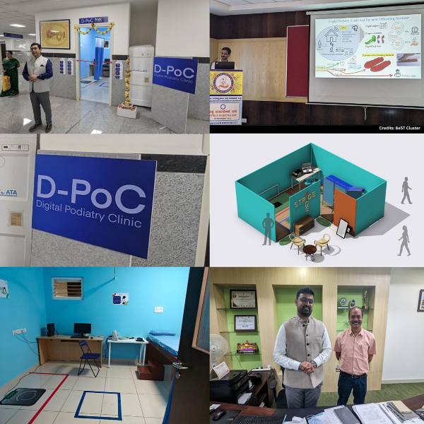
- Manufacturing unit of diabetic footwear is established by the Bangalore S&T Cluster (BeST), at Karnataka Institute of Endocrinology and Research along with a Fully Operational Digital Podiatry Clinic with 100+ walk-ins per day for early screening of diabetic foot.

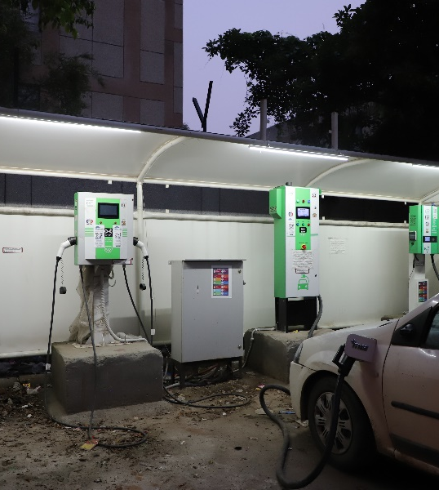
- A suite of Type-2 EV chargers for 2, 3 and 4 wheelers, were developed by Delhi S&T Cluster (DRIIV) and deployed nationwide in 20+ states with the help of PSUs such as IOCL and HPCL in collaboration with the startup EVI Technologies and CART IIT Delhi. Additionally, EV charging stations equipped with battery swapping facilities were deployed across Delhi NCR (Ranibagh, Gurugram, Kapashera), thereby addressing some of the major bottlenecks to EV adoption such as range anxiety and lack of charging infrastructure.
- To enhance ridership and revenue collection of public transport, DRIIV contributed towards the development of the “One Delhi” app, jointly with IIIT Delhi. This multi-modal transit app, adopted by the Delhi Government not only improved access to public transportation for DIMTS buses with features such as real time arrivals tracking and e-ticketing but also allows depot managers to track and manage fleets, for all 7000+ buses, running on 2000+ routes. The app currently experiences an average number of daily ticket sales of 1.5 lakh, with around 3 lakh active users. Ticketing service for Delhi Metro has also been launched recently on this application.
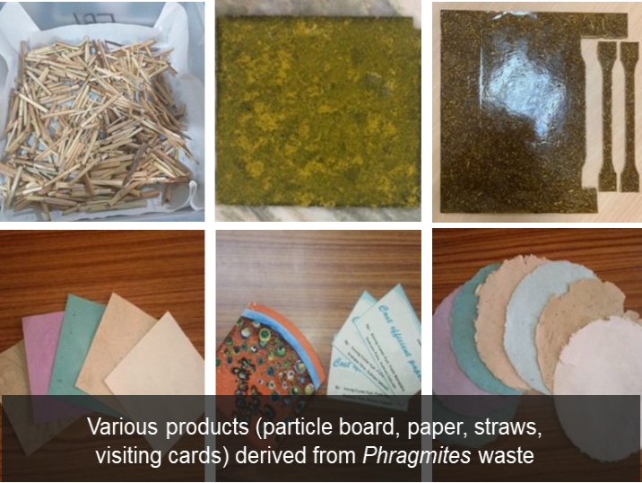
- The Bhubaneshwar S&T Cluster (BCKIC) has facilitated the setting up of manufacturing facility (Pre-Pilot scale) for conversion of Rice Husk/Stubble to Value Added Products, at Pandra, Bhubaneswar. Preliminary scale-up trial at 40% capacity (80 kg rice husk processing) is already completed.
- The Pune Knowledge Cluster (PKC) has built and manages a consortium of over 10 organizations for city level disease surveillance (genomic and environmental) of infectious diseases like COVID-19, Dengue, H1N1, H3N2 and AMR, aligning with the National One Health Mission.

Compendiums

To comprehensively document and showcase the diverse S&T led initiatives undertaken by the Clusters across key thematic areas, dedicated compendiums were launched in November 2024, showcasing key initiatives, outcomes, and success stories. The “Health Compendium” captures pivotal work in pandemic preparedness, digital health, One Health and AMR, and startup support, including BeST’s dengue prediction model, RICH’s AID program, and PKC’s Saksham training. The “Energy & Environment Compendium”, led by DRIIV, focuses on sustainable waste management, mobility, pollution mitigation, and energy transition, featuring efforts like PKC’s Pune Green Hydrogen Valley and Vizag’s e-waste facility. The “STEM Education Compendium” highlights initiatives to strengthen STEM learning and innovation, such as PKC’s ChemAmaze, DRIIV’s executive skilling program, and BCKIC’s “Catch Them Young.” The “Livelihood through S&T Compendium” outlines grassroots empowerment projects like JCKIC’s artisan IP protection and BCKIC’s ROSHNI initiative in Odisha. The “North-East and Industry 4.0 Compendium” emphasizes digital transformation, startup incubation, and regional innovation, with programs like PI-RAHI’s IGNITE and SPARKS. Lastly, the “Agritech Startups Compendium” documents the use of S&T in agriculture, led by RICH, BCKIC, and BeST, to enhance productivity, support agri-innovation, and optimize value chains through precision technologies and stakeholder collaboration. The links to access these compendiums are provided in the bibliography section at the end of this document.

Conclusion
The S&T Clusters in India have evolved into dynamic hubs of innovation, enabling cross-sectoral collaboration and accelerating the translation of scientific research into scalable solutions. By leveraging the idea of integrating academia, industry and government, these Clusters have addressed pressing national challenges with agility and precision. The recent notable contributions of these Clusters include Hyderabad's RICH Cluster Health-Tech AID program supporting 28+ startups with IP and commercialization, while Bengaluru's BeST is integrating climate and clinical data for dengue prediction and advancement in precision agriculture. DRIIV is piloting eco-friendly oil sludge treatment at Numaligarh Refinery, reducing processing time and fostering IP innovation. Pune’s PKC drives climate action through the Green Hydrogen Valley DPR and supports land restoration. AMTZ Vizag strengthens domestic tech capabilities with sustainable e-waste management and indigenous pacemaker lead development, backed by strategic industry-academia collaborations. These interventions exemplify how localized, mission-oriented innovation ecosystems can deliver high socio-economic impact.
Owing to their demonstrated success in fostering technology-driven solutions, S&T clusters are now transitioning into Phase 2.0 of their operation. This next phase focuses on deepening inter-institutional networks, enhancing technology commercialization, providing global solutions to pressing challenges and scaling up impact through sustainable, demand-driven models. The Clusters are expanding their thematic scope to tackle climate resilience, clean energy transitions and digital infrastructure, in alignment with national initiatives like “Atmanirbhar Bharat”, “Make in India”, “Startup India”, “Ayushman Bharat”, etc. to drive progress toward the vision of “Viksit Bharat@2047”. As they mature, these clusters are poised to serve as long-term platforms for inclusive, resilient, and globally competitive research and technological innovation ecosystems in India.

Contact Us
Sr. No. | Name and Designation | Contact Details
1. | Dr. Vishal Choudhary,  Scientist 'F', O/o PSA to the GoI | choudhary.vishal@gov.in;  011 23794553
2. | Mr. Vivek Kumar,  Scientist 'D', O/o PSA to the GoI | vivek.iist@psa.gov.in;  011 23062738
3. | Dr. Shefali Uttam,  Technical Staff | u.shefali@nic.in

Bibliography

- Health: https://psa.gov.in/CMS/web/sites/default/files/publication/COMPENDIUM%20ON%20HEALTH.pdf

- Energy & Environment:
https://psa.gov.in/CMS/web/sites/default/files/publication/Report%20and%20Technology%20Compendium%20SM.pdf

- STEM Education:
https://psa.gov.in/CMS/web/sites/default/files/publication/PKC_STEM_Compendium_October%202024%20SM.pdf

- Livelihood through S&T:
https://psa.gov.in/CMS/web/sites/default/files/publication/Jodhpur_Compendium%20on%20Livelihood%20Through%20Science%20%26%20Technology%20SM.pdf

- North-East and Industry 4.0:
https://psa.gov.in/CMS/web/sites/default/files/publication/Compendium%20on%20NE%20and%20Industry%204.0_All%20Cluster%20Meet%202023_SM.pdf

- Agritech Startups:
https://psa.gov.in/CMS/web/sites/default/files/publication/agritech%20compendium_10June2024.pdf

